Digital Technologies & Hangarau Matihiko 3.8

Level 3, Credits 6, Assessment Internal

# Introduction

This assessment activity requires you to plan, develop and create a digital technologies outcome.

You will be assessed on

* how effectively you use project management tools and techniques to plan and manage the development of a digital outcome
* how effectively you decompose the problem into smaller components, and test and refine your media outcome so that it is a high-quality response to the task
* how well you have addressed relevant implications
* how well you synthesise information from the planning, testing and trialling of components to develop a high-quality response to the task (e.g. well-structured, logical, flexible, robust and comprehensively tested program)
* discuss how this information assisted in the development of a high-quality outcome

# Problem Statement

* Write your chosen problem statement here. If you are choosing an option from the website, copy-paste it here.

## Option 2: Find the Treasure

Teach an educational topic of your choice by developing a graphical adventure game.

Unlike option 1, which is a straight-forward quiz, you must create a scenario for this — adventuring to best a monster, solving a mystery, escaping from a dungeon, etc.

### Requirements

1. the game must include a 10x10 grid (or larger) to walk around
   * the grid tiles could represent locations
   * certain tiles could contain items/dangers
2. each turn, the user should be able to move a tile and/or perform an action at that tile
3. the game must include a stamina system
   * every few actions that the user takes should deplete the user’s stamina
   * specific actions and/or items can replenish the user’s stamina
   * if the user runs out of stamina, the game is over
4. the game must have a well-defined victory condition
   * what must happen for the game to be “won”?
   * what steps must occur for this to happen?
   * what could go wrong for the player?
5. how you integrate the object-oriented programming knowledge into the game is up to you, but it must be present and directly lead to the victory condition
   * for example, deciphering a clue could lead to the correct place on the map to find the next clue, and so on
   * if you are unsure, consult with your teacher

# Decomposing the outcome

### Decomposing the digital technologies outcome into smaller components

* Decompose your digital technologies outcome into smaller components and rank the priority of each component.

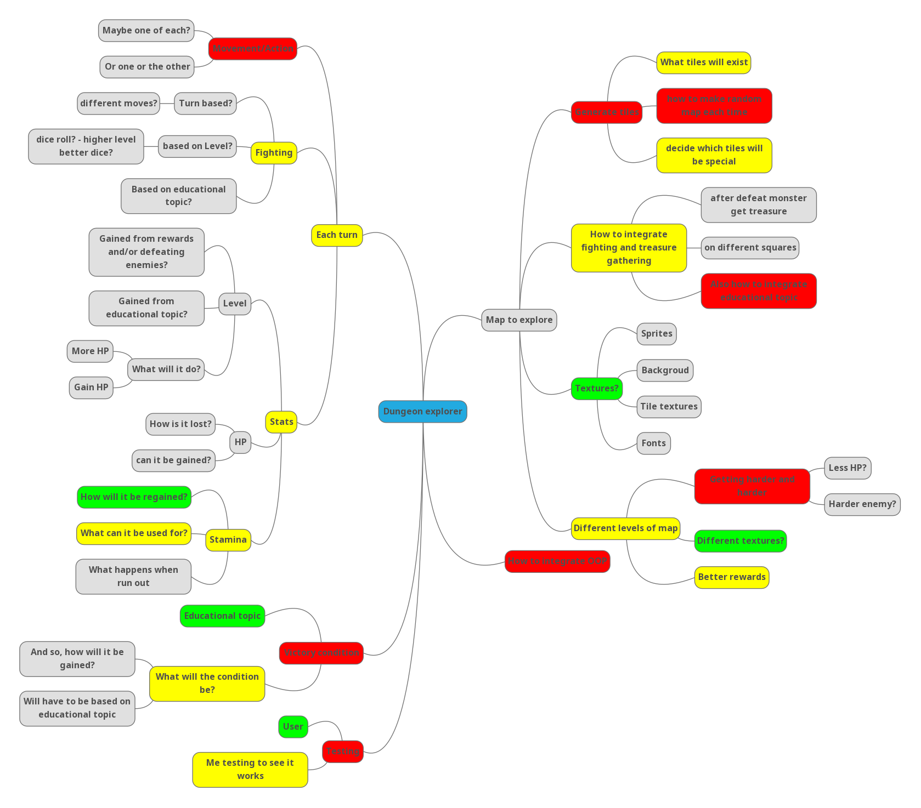

# Relevant Implications

### Addressing relevant implications

* *What relevant implications do you need to consider in the development of your outcome? Describe which you will address in its development.*

*Examples of relevant implications include:*

|  |  |  |  |  |  |
| --- | --- | --- | --- | --- | --- |
| *Social* | *Cultural* | *Legal* | *Ethical* | *Intellectual property* | *Accessibility* |
| *Usability* | *Functionality* | *Aesthetics* | *Sustainability & future-proofing* | *End-user requirements* | *Health & safety* |

### Implication #1: Intellectual Property

According to [google](https://languages.oup.com/google-dictionary-en/), intellectual property is “Intangible property that is the result of creativity, such as patents, copyrights, etc.”, this means that I will not be able to use such properties that I do not have direct approval from the owner to use in my project.

This means that ideas, images, and code that others have made, I will not be able to use in my project, like sprites, textures, specific game mechanics from individual games, and algorithms and code snippets from the internet.

In order to address this relevant implication, I will either get my images from open source places, using the advanced google images filter, or make my own. I will get ideas for the game from my own brain, and from open source games. Lastly, I will get my code snippets from open source places like stack overflow, and Wikipedia, and the like.

### Implication #2: Aesthetics

Explain the implication here

Link the implication to your outcome here

Explain how you will **address** the implication

# Sprint #1

### Using recognised and appropriate project management tools and techniques to plan the development of a digital technologies outcome

## Planning

* When did this sprint start, and when is it projected to end?

**START DATE** START DATE HERE

**FINISH DATE** FINISH DATE HERE

* What components will work on during this sprint?

Type here

* Provide evidence (screenshot / photo) of your project management tool(s) being used to plan the development of your outcome at the beginning of your sprint here

Screenshot here

## Development

* What component(s) will you to trial?

Type here

* Provide evidence of the option for each component you are going to trial, such as screenshots or explanations

### Component 1

|  |  |
| --- | --- |
| Option 1 |  |
| Option 2 |  |
| Option 3 |  |

### Component 2 (If you are only trialling one component this sprint, delete this table)

|  |  |
| --- | --- |
| Option 1 |  |
| Option 2 |  |
| Option 3 |  |

## Feedback

**Remember, for any component you trial, you should receive multiple feedback for it.  
Don’t get JUST one feedback per trialled component!**

**Component trialled** COMPONENT HERE

**Feedback giver** NAME HERE **Date trialled** DATE HERE

Type feedback here

**Component trialled** COMPONENT HERE

**Feedback giver** NAME HERE **Date trialled** DATE HERE

Type feedback here

**Component trialled** COMPONENT HERE

**Feedback giver** NAME HERE **Date trialled** DATE HERE

Type feedback here

* What decision have you made based on this feedback? Explain:
* *whether or not you will choose the most highly rated option, and why*
* *what changes you will incorporate, and why*
* *what suggestions you will* ***not*** *incorporate, and why*

Type here

## Testing

* What components are you testing?

Type here

|  |  |  |  |  |  |
| --- | --- | --- | --- | --- | --- |
| **Type of test (E, B, I)** | **Method to Test** | **Value(s) to enter** | **Expected result** | **Actual result (screen snip / time stamp)** | **Comments/ changes needed** |
|  |  |  |  |  |  |
|  |  |  |  |  |  |
|  |  |  |  |  |  |
|  |  |  |  |  |  |
|  |  |  |  |  |  |
|  |  |  |  |  |  |
|  |  |  |  |  |  |
|  |  |  |  |  |  |

## Evaluation

* What components did you complete in this sprint? How do you know they are completed?

Type here

* What components’ development will carry on into the next sprint? Why?

Type here

* Provide evidence (screenshot) of your version control

Screenshot here

* Provide evidence (screenshot / photo) of your project management tool(s) being used to manage the development of your outcome at the end of your sprint here

Screenshot here

# Sprint #2

### Using recognised and appropriate project management tools and techniques to plan the development of a digital technologies outcome

## Planning

* When did this sprint start, and when is it projected to end?

**START DATE** START DATE HERE

**FINISH DATE** FINISH DATE HERE

* What components will work on during this sprint?

Type here

* Provide evidence (screenshot / photo) of your project management tool(s) being used to plan the development of your outcome at the beginning of your sprint here

Screenshot here

## Development

* What component(s) will you to trial?

Type here

* Provide evidence of the option for each component you are going to trial, such as screenshots or explanations

### Component 1

|  |  |
| --- | --- |
| Option 1 |  |
| Option 2 |  |
| Option 3 |  |

### Component 2 (If you are only trialling one component this sprint, delete this table)

|  |  |
| --- | --- |
| Option 1 |  |
| Option 2 |  |
| Option 3 |  |

## Feedback

**Remember, for any component you trial, you should receive multiple feedback for it.  
Don’t get JUST one feedback per trialled component!**

**Component trialled** COMPONENT HERE

**Feedback giver** NAME HERE **Date trialled** DATE HERE

Type feedback here

**Component trialled** COMPONENT HERE

**Feedback giver** NAME HERE **Date trialled** DATE HERE

Type feedback here

**Component trialled** COMPONENT HERE

**Feedback giver** NAME HERE **Date trialled** DATE HERE

Type feedback here

* What decision have you made based on this feedback? Explain:
* *whether or not you will choose the most highly rated option, and why*
* *what changes you will incorporate, and why*
* *what suggestions you will* ***not*** *incorporate, and why*

Type here

## Testing

* What components are you testing?

Type here

|  |  |  |  |  |  |
| --- | --- | --- | --- | --- | --- |
| **Type of test (E, B, I)** | **Method to Test** | **Value(s) to enter** | **Expected result** | **Actual result (screen snip / time stamp)** | **Comments/ changes needed** |
|  |  |  |  |  |  |
|  |  |  |  |  |  |
|  |  |  |  |  |  |
|  |  |  |  |  |  |
|  |  |  |  |  |  |
|  |  |  |  |  |  |
|  |  |  |  |  |  |
|  |  |  |  |  |  |

## Evaluation

* What components did you complete in this sprint? How do you know they are completed?

Type here

* What components’ development will carry on into the next sprint? Why?

Type here

* Provide evidence (screenshot) of your version control

Screenshot here

* Provide evidence (screenshot / photo) of your project management tool(s) being used to manage the development of your outcome at the end of your sprint here

Screenshot here

# Sprint #3

### Using recognised and appropriate project management tools and techniques to plan the development of a digital technologies outcome

## Planning

* When did this sprint start, and when is it projected to end?

**START DATE** START DATE HERE

**FINISH DATE** FINISH DATE HERE

* What components will work on during this sprint?

Type here

* Provide evidence (screenshot / photo) of your project management tool(s) being used to plan the development of your outcome at the beginning of your sprint here

Screenshot here

## Development

* What component(s) will you to trial?

Type here

* Provide evidence of the option for each component you are going to trial, such as screenshots or explanations

### Component 1

|  |  |
| --- | --- |
| Option 1 |  |
| Option 2 |  |
| Option 3 |  |

### Component 2 (If you are only trialling one component this sprint, delete this table)

|  |  |
| --- | --- |
| Option 1 |  |
| Option 2 |  |
| Option 3 |  |

## Feedback

**Remember, for any component you trial, you should receive multiple feedback for it.  
Don’t get JUST one feedback per trialled component!**

**Component trialled** COMPONENT HERE

**Feedback giver** NAME HERE **Date trialled** DATE HERE

Type feedback here

**Component trialled** COMPONENT HERE

**Feedback giver** NAME HERE **Date trialled** DATE HERE

Type feedback here

**Component trialled** COMPONENT HERE

**Feedback giver** NAME HERE **Date trialled** DATE HERE

Type feedback here

* What decision have you made based on this feedback? Explain:
* *whether or not you will choose the most highly rated option, and why*
* *what changes you will incorporate, and why*
* *what suggestions you will* ***not*** *incorporate, and why*

Type here

## Testing

* What components are you testing?

Type here

|  |  |  |  |  |  |
| --- | --- | --- | --- | --- | --- |
| **Type of test (E, B, I)** | **Method to Test** | **Value(s) to enter** | **Expected result** | **Actual result (screen snip / time stamp)** | **Comments/ changes needed** |
|  |  |  |  |  |  |
|  |  |  |  |  |  |
|  |  |  |  |  |  |
|  |  |  |  |  |  |
|  |  |  |  |  |  |
|  |  |  |  |  |  |
|  |  |  |  |  |  |
|  |  |  |  |  |  |

## Evaluation

* What components did you complete in this sprint? How do you know they are completed?

Type here

* What components’ development will carry on into the next sprint? Why?

Type here

* Provide evidence (screenshot) of your version control

Screenshot here

* Provide evidence (screenshot / photo) of your project management tool(s) being used to manage the development of your outcome at the end of your sprint here

Screenshot here

# Sprint #4

### Using recognised and appropriate project management tools and techniques to plan the development of a digital technologies outcome

## Planning

* When did this sprint start, and when is it projected to end?

**START DATE** START DATE HERE

**FINISH DATE** FINISH DATE HERE

* What components will work on during this sprint?

Type here

* Provide evidence (screenshot / photo) of your project management tool(s) being used to plan the development of your outcome at the beginning of your sprint here

Screenshot here

## Development

* What component(s) will you to trial?

Type here

* Provide evidence of the option for each component you are going to trial, such as screenshots or explanations

### Component 1

|  |  |
| --- | --- |
| Option 1 |  |
| Option 2 |  |
| Option 3 |  |

### Component 2 (If you are only trialling one component this sprint, delete this table)

|  |  |
| --- | --- |
| Option 1 |  |
| Option 2 |  |
| Option 3 |  |

## Feedback

**Remember, for any component you trial, you should receive multiple feedback for it.  
Don’t get JUST one feedback per trialled component!**

**Component trialled** COMPONENT HERE

**Feedback giver** NAME HERE **Date trialled** DATE HERE

Type feedback here

**Component trialled** COMPONENT HERE

**Feedback giver** NAME HERE **Date trialled** DATE HERE

Type feedback here

**Component trialled** COMPONENT HERE

**Feedback giver** NAME HERE **Date trialled** DATE HERE

Type feedback here

* What decision have you made based on this feedback? Explain:
* *whether or not you will choose the most highly rated option, and why*
* *what changes you will incorporate, and why*
* *what suggestions you will* ***not*** *incorporate, and why*

Type here

## Testing

* What components are you testing?

Type here

|  |  |  |  |  |  |
| --- | --- | --- | --- | --- | --- |
| **Type of test (E, B, I)** | **Method to Test** | **Value(s) to enter** | **Expected result** | **Actual result (screen snip / time stamp)** | **Comments/ changes needed** |
|  |  |  |  |  |  |
|  |  |  |  |  |  |
|  |  |  |  |  |  |
|  |  |  |  |  |  |
|  |  |  |  |  |  |
|  |  |  |  |  |  |
|  |  |  |  |  |  |
|  |  |  |  |  |  |

## Evaluation

* What components did you complete in this sprint? How do you know they are completed?

Type here

* What components’ development will carry on into the next sprint? Why?

Type here

* Provide evidence (screenshot) of your version control

Screenshot here

* Provide evidence (screenshot / photo) of your project management tool(s) being used to manage the development of your outcome at the end of your sprint here

Screenshot here

# Project Summary

### Addressing relevant implications

* How did you **address** the relevant implications in the development of this outcome?

Type here

### Synthesising information gained from the planning, testing and trialling of components

* How did the process, tools, and techniques you used in each sprint help to shape the development of your outcome? Provide evidence.

Type here

* How did testing and trialling shape the development of your outcome? Provide evidence.

Type here